Yara Jamal shell script

Lab3

1. Write a script called mycase, using the case utility to checks the type of character

entered by a user:

a. Upper Case.

b. Lower Case.

c. Number.

d. Nothing.

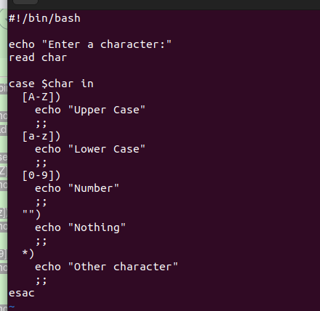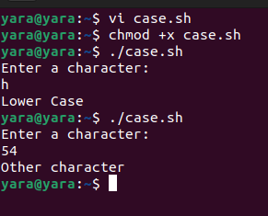

2. Enhanced the previous script, by checking the type of string entered by a user: a. Upper Cases. b. Lower Cases. c. Numbers. d. Mix. e. Nothing.

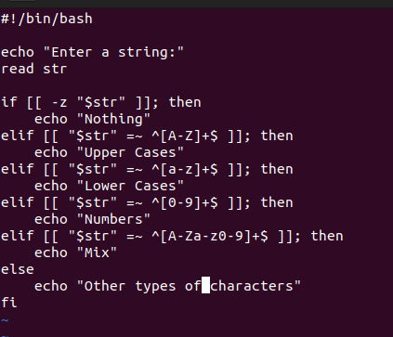

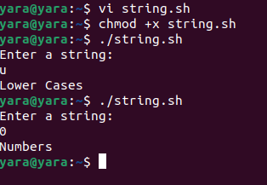

3- Write a script called mychmod using for utility to give execute permission to all files and directories in your home directory

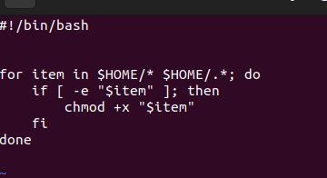

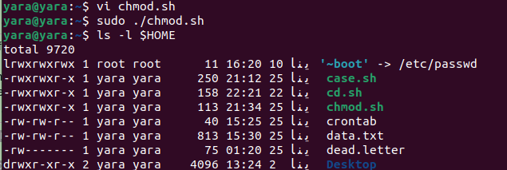

4. Write a script called mybackup using for utility to create a backup of only files in your directory.

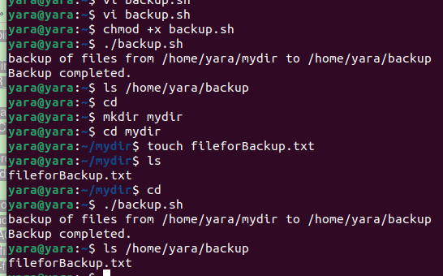

5. Write a script called mymail using for utility to send a mail to all users in the system. Note: write the mail body in a file called mtemplate.

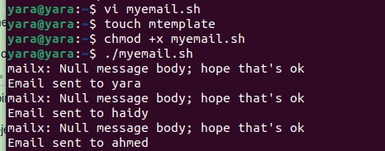

6. Write a script called chkmail to check for new mails every 10 seconds. Note: mails are saved in /var/mail/username.

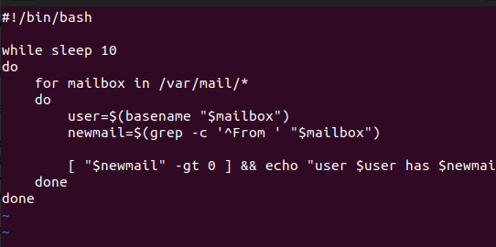

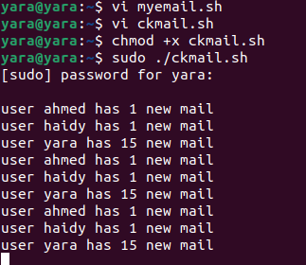

7-

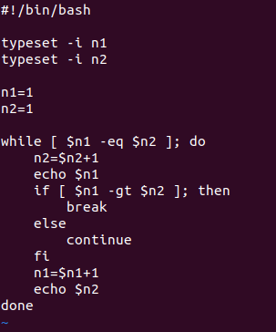



- 8. Create the following menu:

a. Press 1 to ls

b. Press 2 to ls –a

c. Press 3 to exit

Using select utility then while utility.

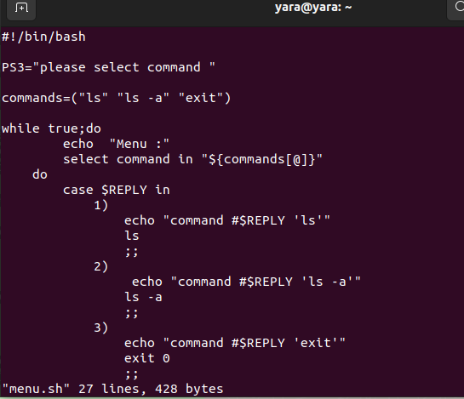

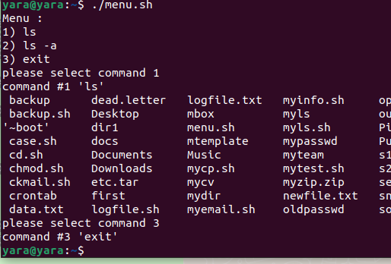

9. Write a script called myarr that ask a user how many elements he wants to enter in an

array, fill the array and then print it.

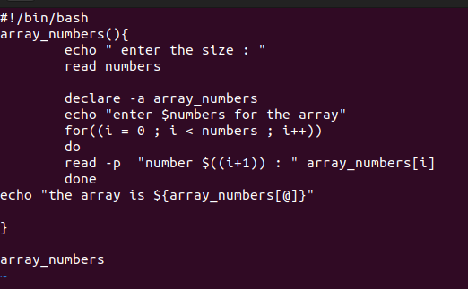

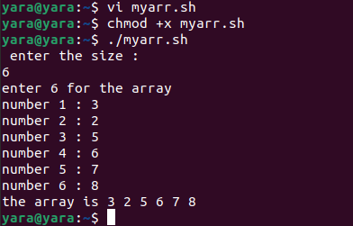

10.Write a script called myavg that calculate average of all numbers entered by a user. Note: use arrays

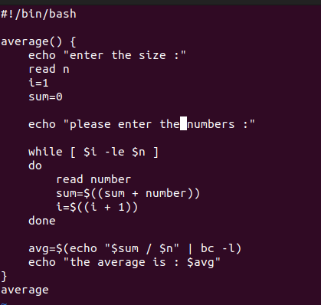

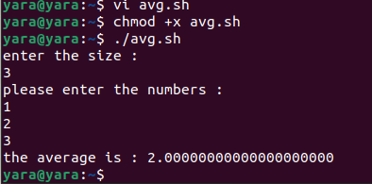

11.Write a function called mysq that calculate square if its argument.

